Project Report

Black Africa Faith Settings – Six-Month Health Promotion Programme

Project Overview
The Black Africa Faith Settings – Six-Month Health Promotion Programme was implemented within Tower Hamlets by the Christ Apostolic Church (CAC), in collaboration with local partners.
The project aimed to:
- Engage Black African faith communities in Tower Hamlets with opportunities to improve their health outcomes.
- Support community members in accessing health and well-being services.
- Empower and build trust, resilience, and capacity within the Black African community to deliver services and support through a Black African-led organization.

1. Objectives
- To engage Black African faith communities in Tower Hamlets with opportunities to improve their health outcomes and access health and well-being services.
- To empower and build trust within the Black African community by equipping them with the tools, knowledge, and resources to support their health.
- To foster resilience and strengthen the capacity of Black African-led organizations to deliver ongoing health initiatives.

2. Target Audience
The programme specifically targeted Black African and Caribbean communities in Tower Hamlets, including individuals and families attending local faith centres and community spaces.

3. Activities and Implementation
The following activities were carried out:
- Street Campaigns: Promoting health awareness and distributing educational materials.
- Talk Sessions: Focused discussions on health, wellness, and access to services.
- Training Workshops: Practical sessions on simple health management strategies.
Delivery Methods:
- Activities were delivered in-person at community and faith settings.
- Social media platforms were used to extend outreach and engagement.
- Workshops & Talk Sessions provided structured opportunities for learning and discussion.

4. Outcomes and Impact
The programme successfully achieved its intended outcomes:
- Empowered the Black African community in Tower Hamlets to identify and take practical steps towards improving their health outcomes.
- Increased community engagement with health promotion opportunities.
- Strengthened health literacy, especially around prevention, risk awareness, and management of health conditions.
- Built greater trust in statutory health services, reducing barriers to access.
Community Impact Highlights:
- Higher participation in health-related activities.
- Improved knowledge of available services.
- Stronger collaboration between faith institutions and health providers.

5. Challenges
- Funding restrictions limited the scope of physical projects within some faith centres. In such cases, project content was integrated into sermons (e.g., CAC Pilgrims Tabernacle, RCCG Jubilee Parish).
- Differences in beliefs about health and wellness sometimes created barriers.
- Language barriers required translation/interpretation for broader engagement.
- Cultural habits and ingrained practices were difficult to overcome within a short programme period.
We also have challenges in securing funds as a result of:
- Ineligible because of our type of work
- Grant size too large
- The size of our organization
- We keep getting rejected application
- Dead line are just too close. Etc.

6. Budget and Resources
- Total Budget: £17,657
- Funding Body: Department of Public Health, Tower Hamlets
- Partners: Social Health Network (supported some training sessions)

7. Evaluation
The success of the programme was measured using:
- Case Studies to capture individual impact stories.
- Attendance Records to monitor participation trends.
- Feedback Forms from attendees, assessing satisfaction and learning outcomes.

8. Recommendations & Next Steps
Building on the success of this six-month programme, the following are recommended:
1. Sustainability & Scale-Up:
- Apply for longer-term funding to extend the programme into a year-round initiative.
- Replicate the model in other neighbourhood with large Black African and Caribbean populations.
2. Institutional Development:
- Establish a Community Wellness Hub within Tower Hamlets, serving as a trusted space for ongoing support and resources.
3. Broader Engagement:
- Increase collaboration with local health services and other community organizations.
- Expand translation services to improve inclusivity.
- Explore digital platforms for wider reach, particularly among younger demographics.

Suggested solution to the challenges in securing funds.
Recommend more tailored funding pots (for micro, grassroots, faith-based, or new groups).
Suggest partnerships where small groups can apply jointly.
Encourage flexible grant sizes so both small and larger groups can access appropriate funding.
Suggest funders allow organisations to scale their request based on capacity.
Recommend maintaining an open “rolling application” system for urgent needs.
Suggest funders signpost alternative funding sources when closed. Recommend longer application windows.
Suggest a clear annual funding calendar published in advance.Funders should prioritise simpler processes, flexibility, capacity-building, and feedback. Community groups would benefit from collaborations, training, and advocacy for fairer access. Tower hamlets council of voluntary sectors (THCVS) in their state of the sector pasted below, made a staggering revelation, and an urgent case for continued support in the things that organisation that impacts community.
NEL VCFSE ‘State of the Sector’ report
In February 2025, we conducted a ‘state of the sector’ survey to help us understand the current climate of VCFSE across NEL. Here, we conducted a survey and received 158 responses. Alongside this survey, we are analysing the Charities Commission data to give a broader overview of the VCFSE in North East London.
The data drawn from the survey and wider analysis have now been shared as a report and can be accesses here.
The North East London (NEL) Voluntary, Community, Faith and Social Enterprise (VCFSE) sector plays a vital role in supporting one of the most diverse and deprived regions in the country. The aim of the report is to inform strategic action by highlighting challenges, gaps, and opportunities, especially as the sector faces rising demand, funding pressures and significant changes to ICB operating models. With over 2 million residents and a projected increase of 400,000 by 2041, NEL is marked by severe health inequalities and deprivation—notably in Barking and Dagenham, City and Hackney, Newham and Tower Hamlets. These pressures intensify the critical support role played by VCFSE organisations.
Some of the key findings include:
• 5,534 VCFSE organisations operate locally and regionally across North East London, employing 22,626 people and engaging 98,247 volunteers (as well as 14,992 trustees).
• 61% of organisations have annual incomes under £100,000, including 30% with an annual income of under £10,000, indicating a predominantly small-scale, grassroots sector.
• Only 20% of organisations report secure funding, with 37% having no secured funding for the next 12 months.
• Global Majority-led organisations face disproportionate financial challenges, with 61% reporting deteriorating financial situations.
• Limited integration with NHS systems, with only 13% receiving health-related funding despite 43% receiving NHS referrals.
Recommendations and next steps
There are clear actions to progress with in the coming months which include improving supporting smaller organisations, especially those that are Global Majority-led.
The report shows that while the North East London VCFSE sector is substantial, it faces serious financial and operational challenges. Action on diversity, funding, partnerships and infrastructure is essential to safeguard the sector’s resilience and to maintain its vital role in tackling health inequalities and supporting North East London’s diverse communities.
In the light of policy context, with care moving closer to home and the shift from treatment to prevention, the role of VCFSE in addressing health inequalities is vital, as they hold the trust and expertise and access to the communities they work with.

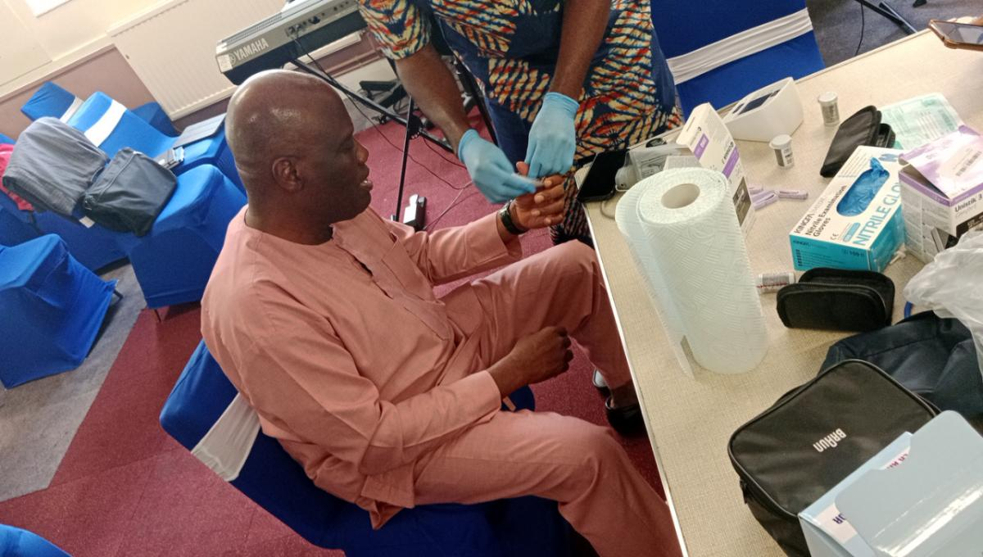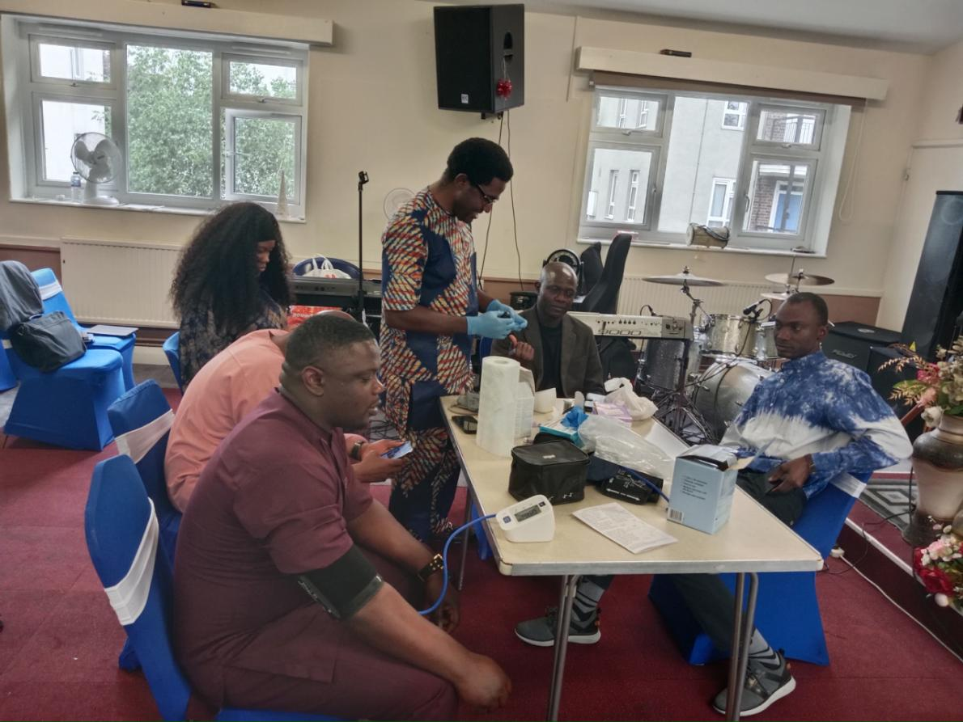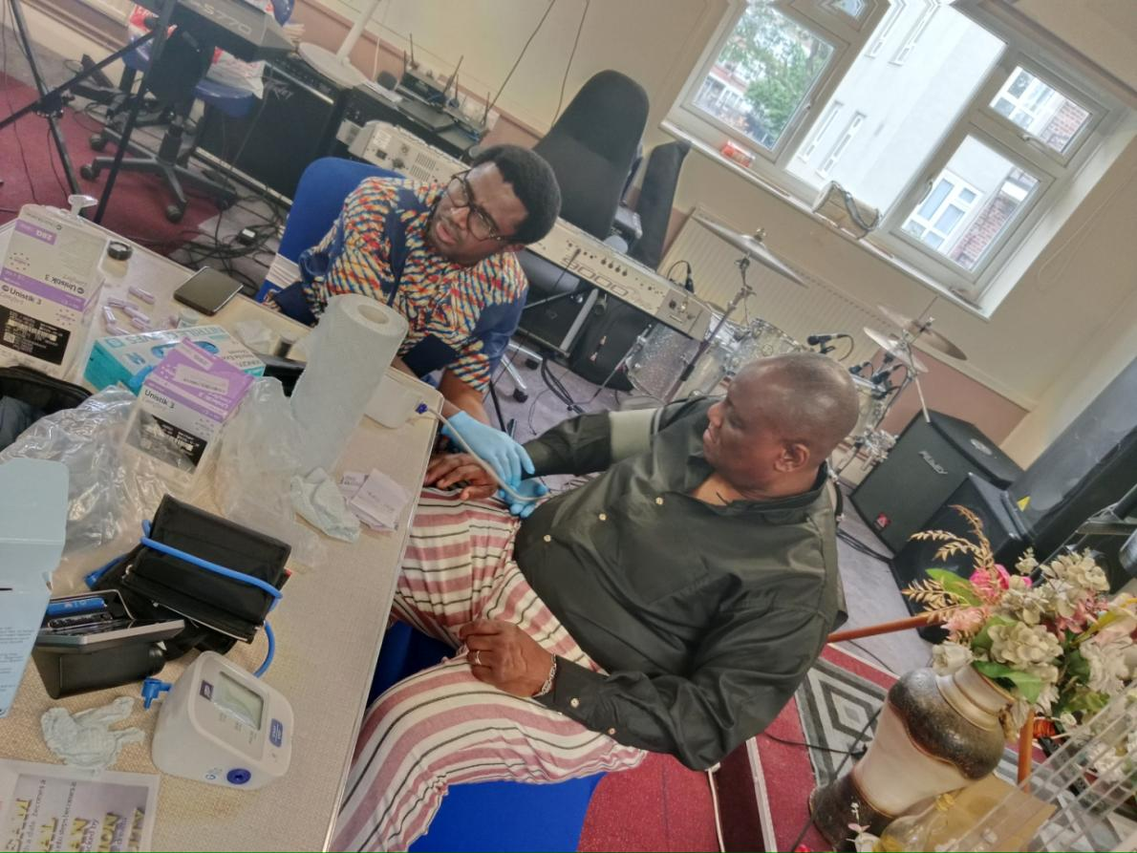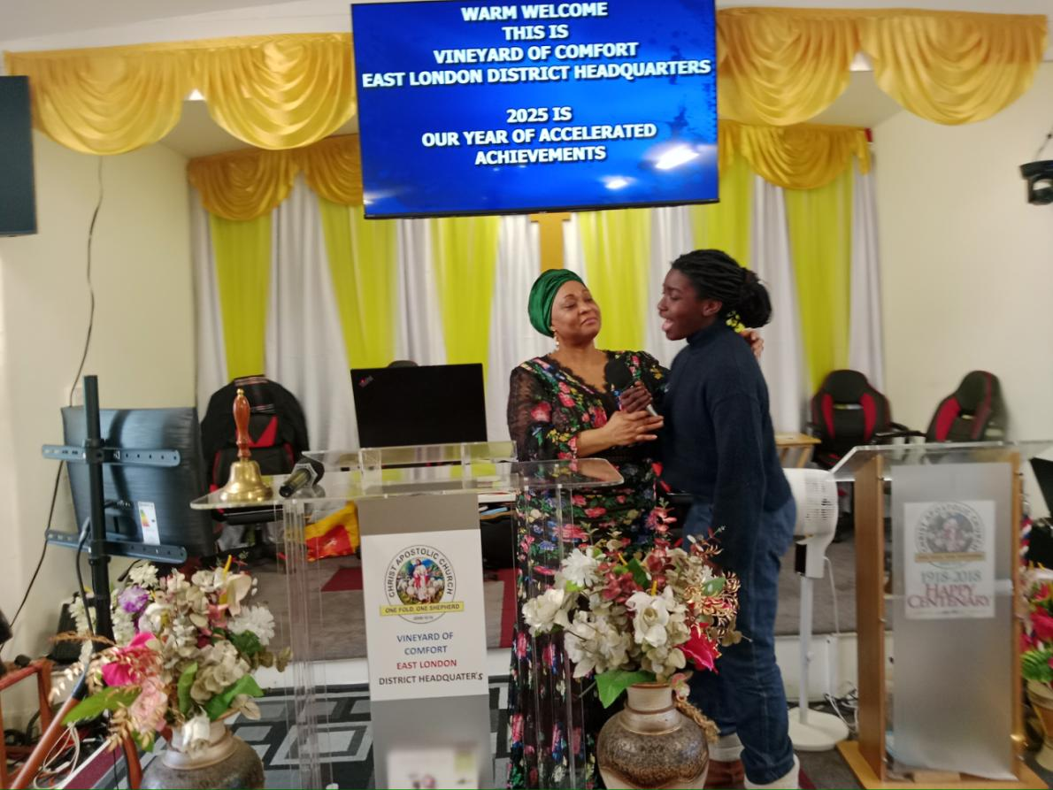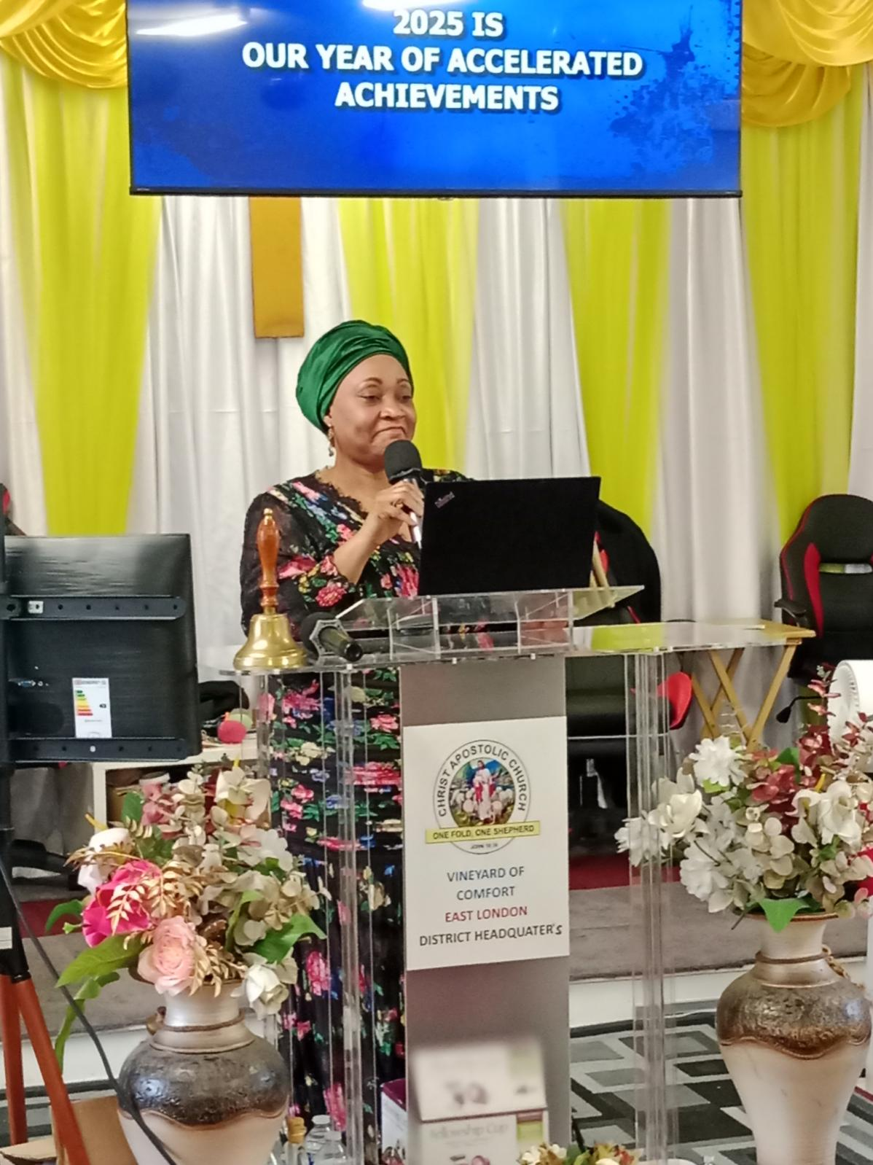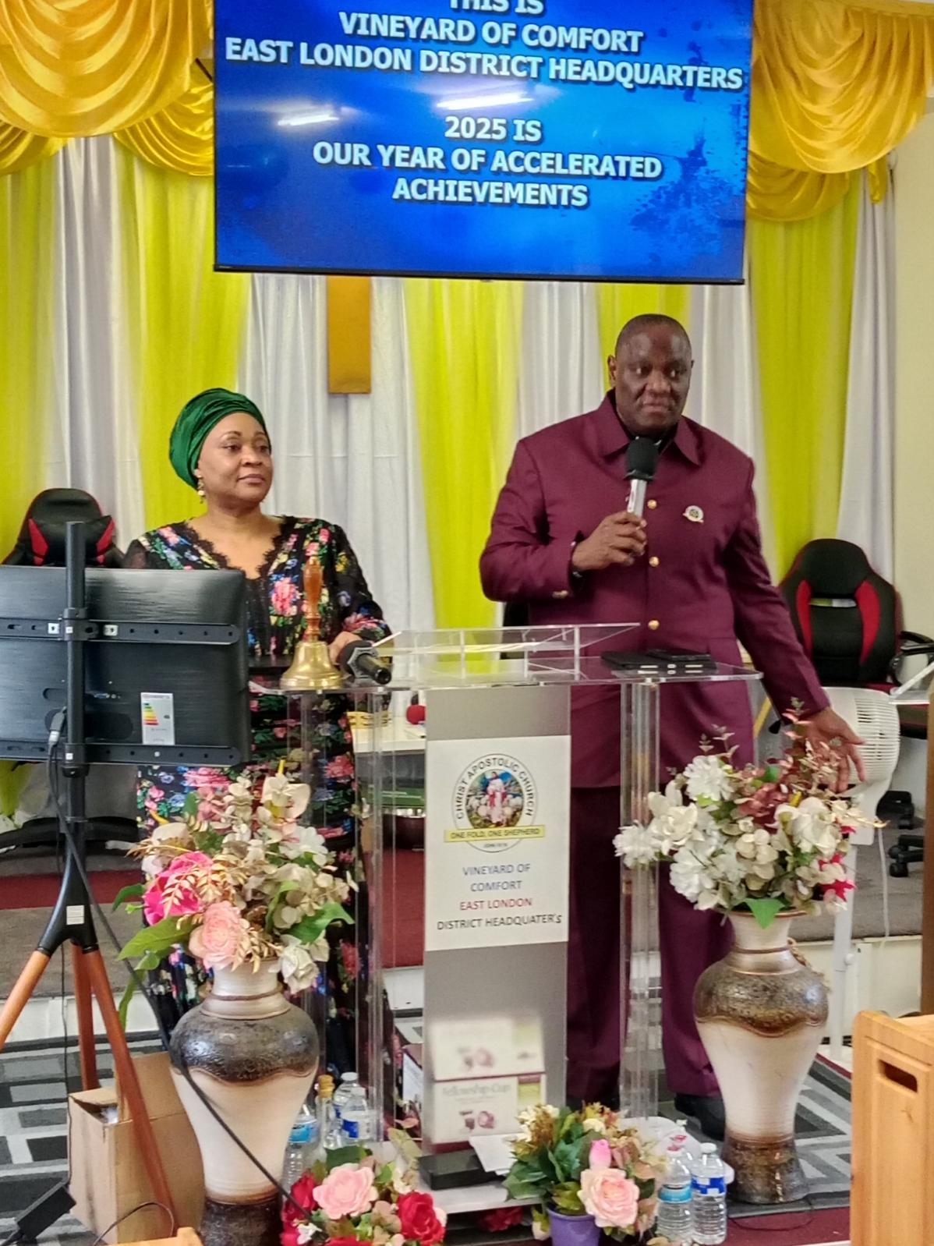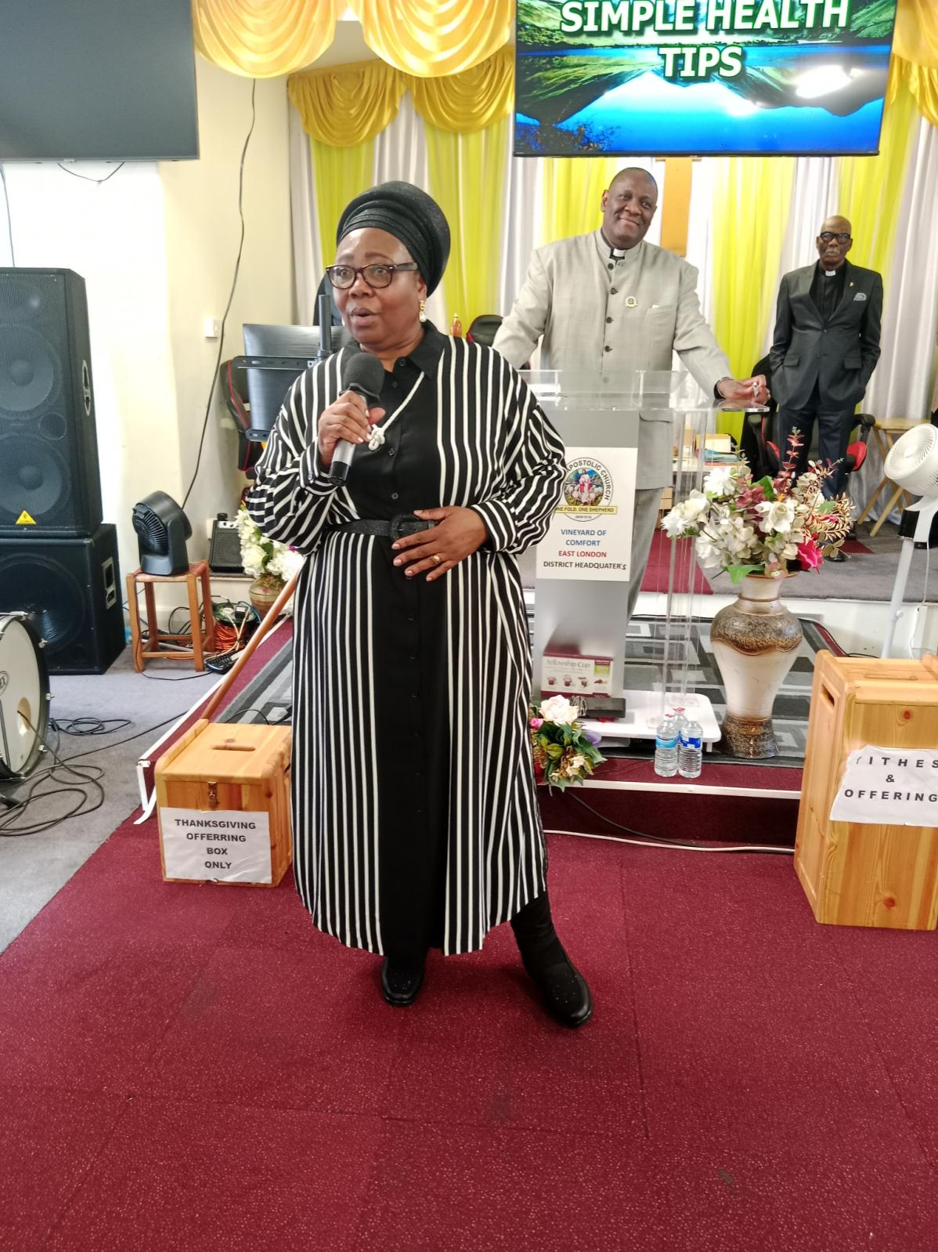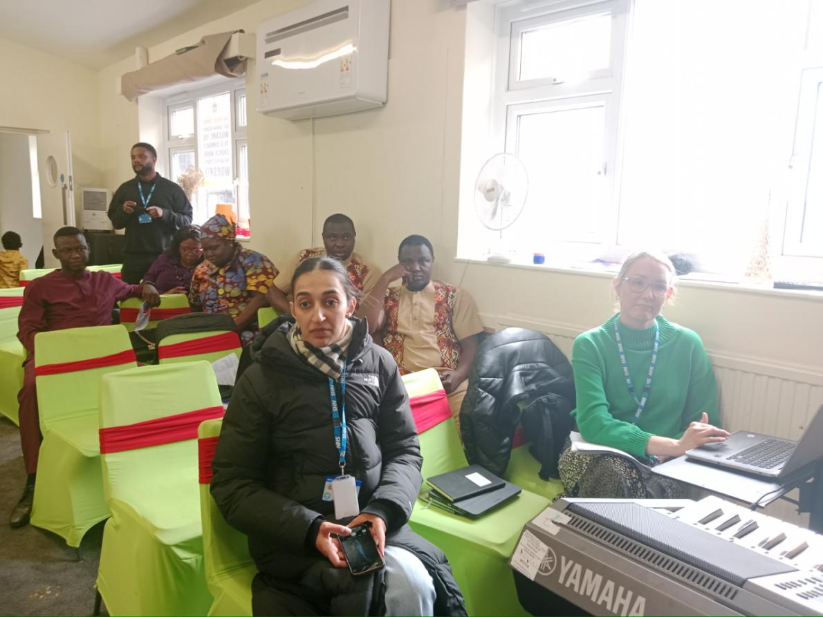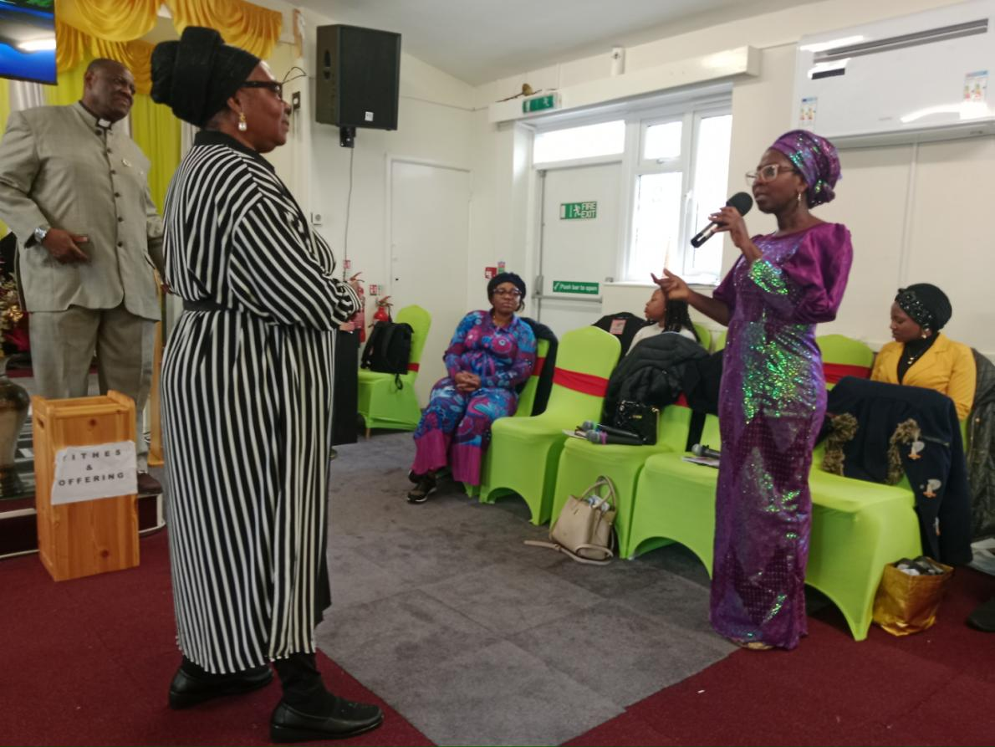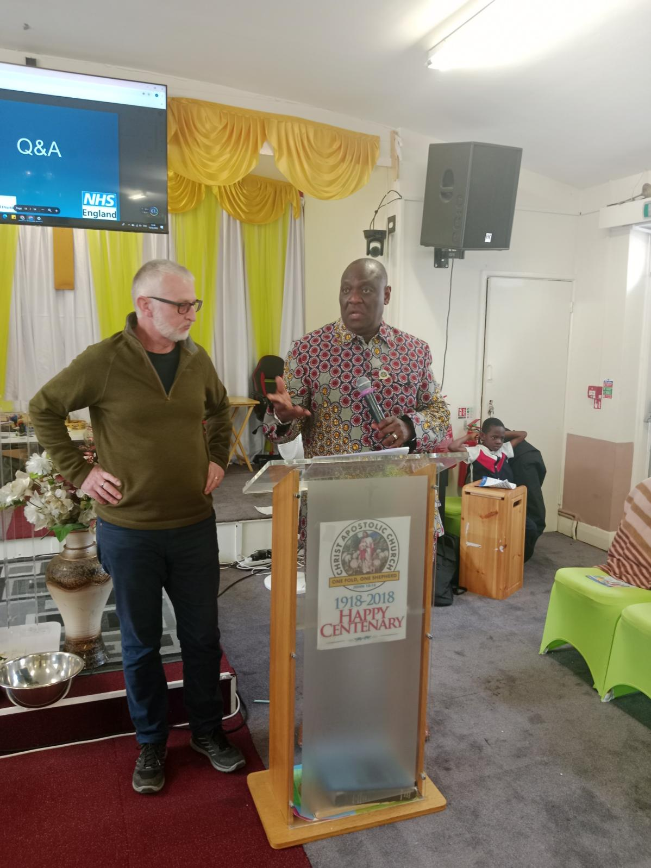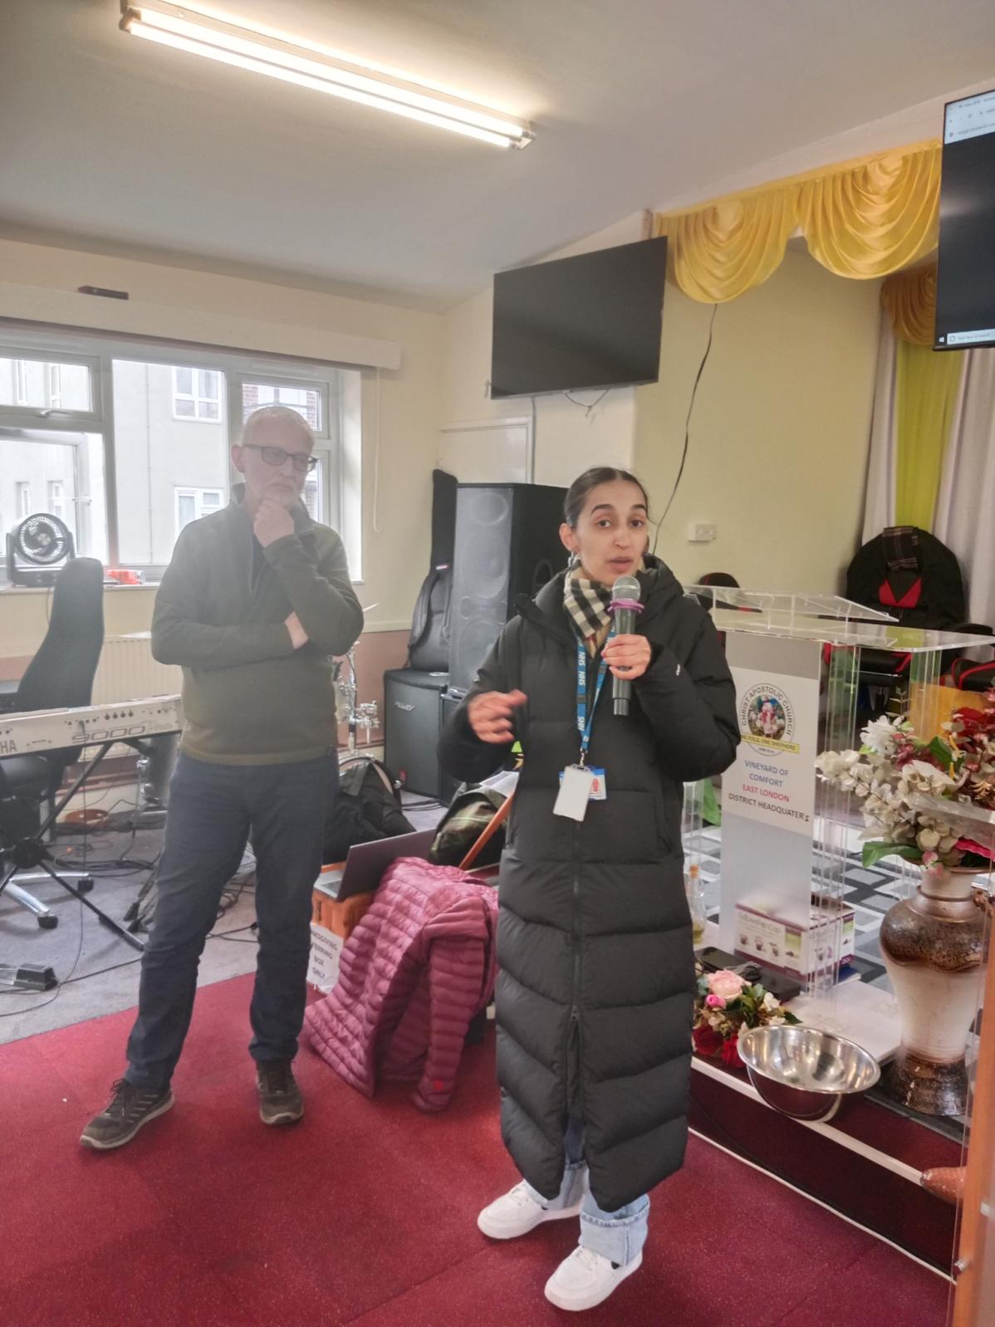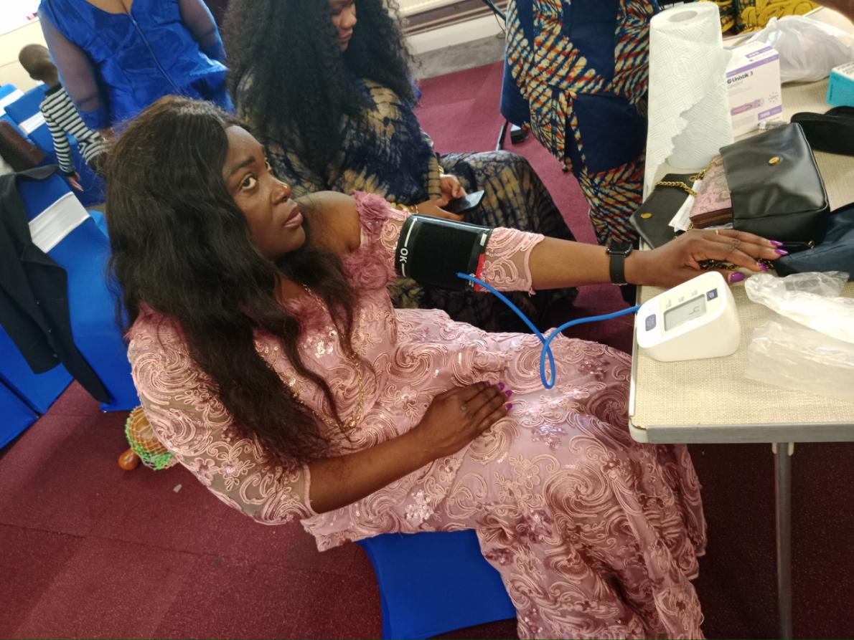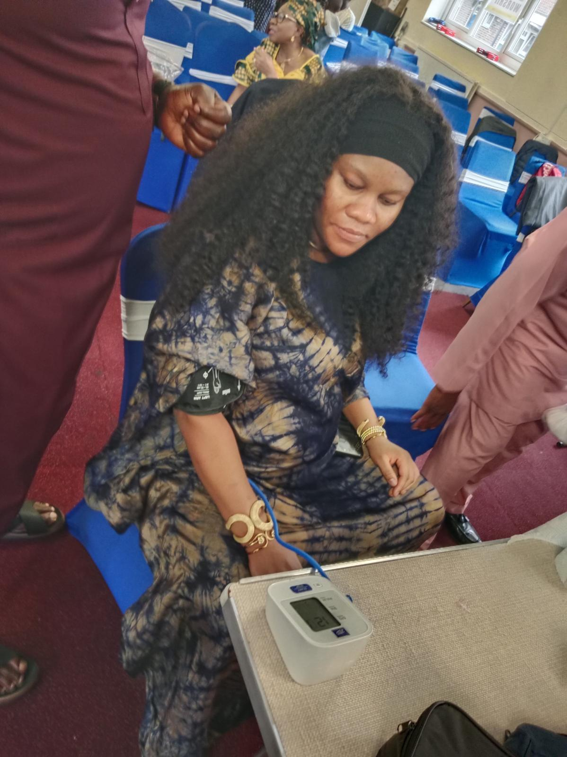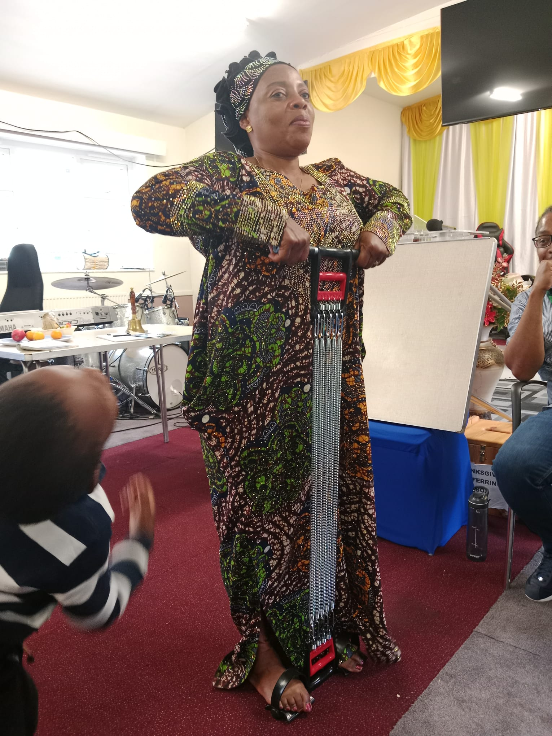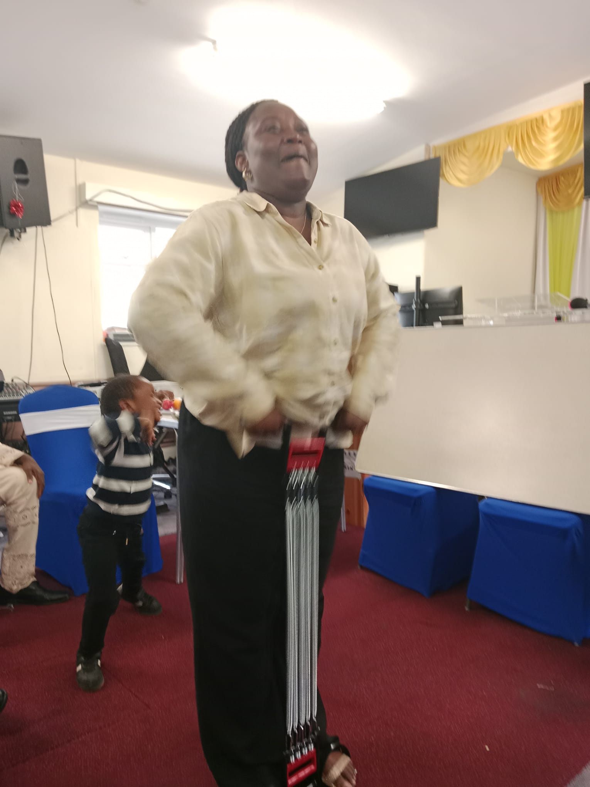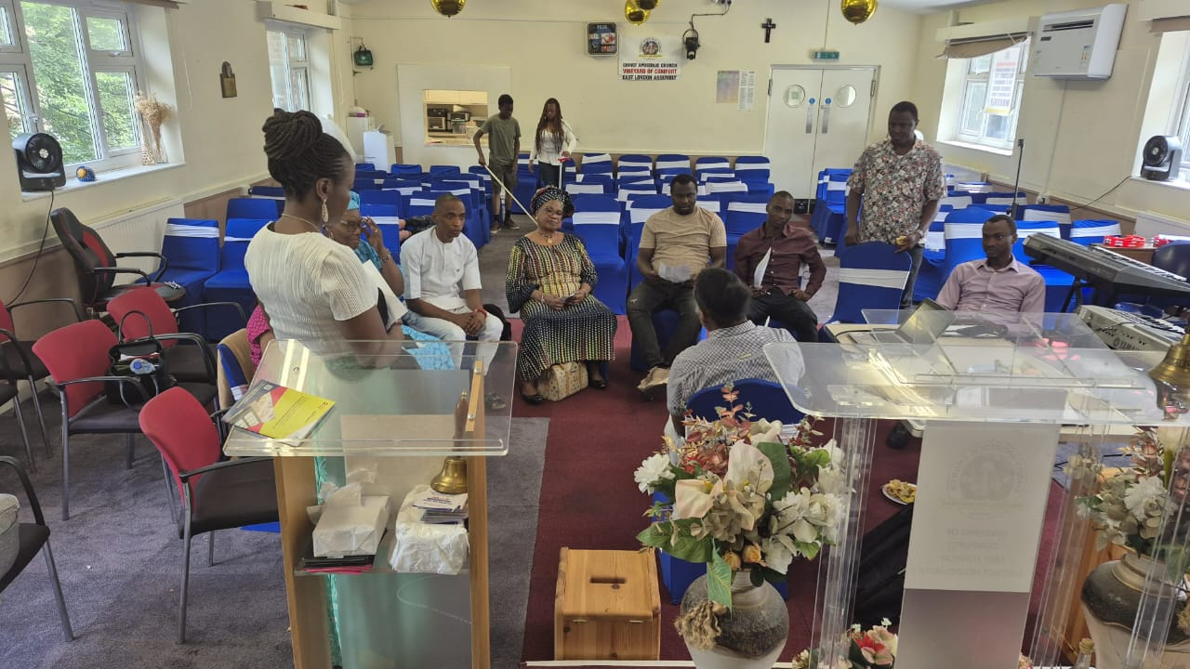

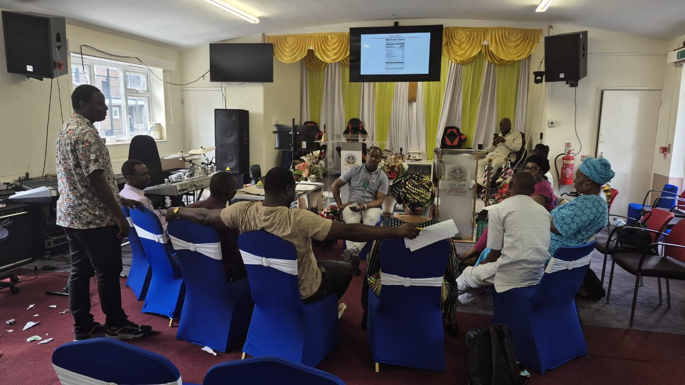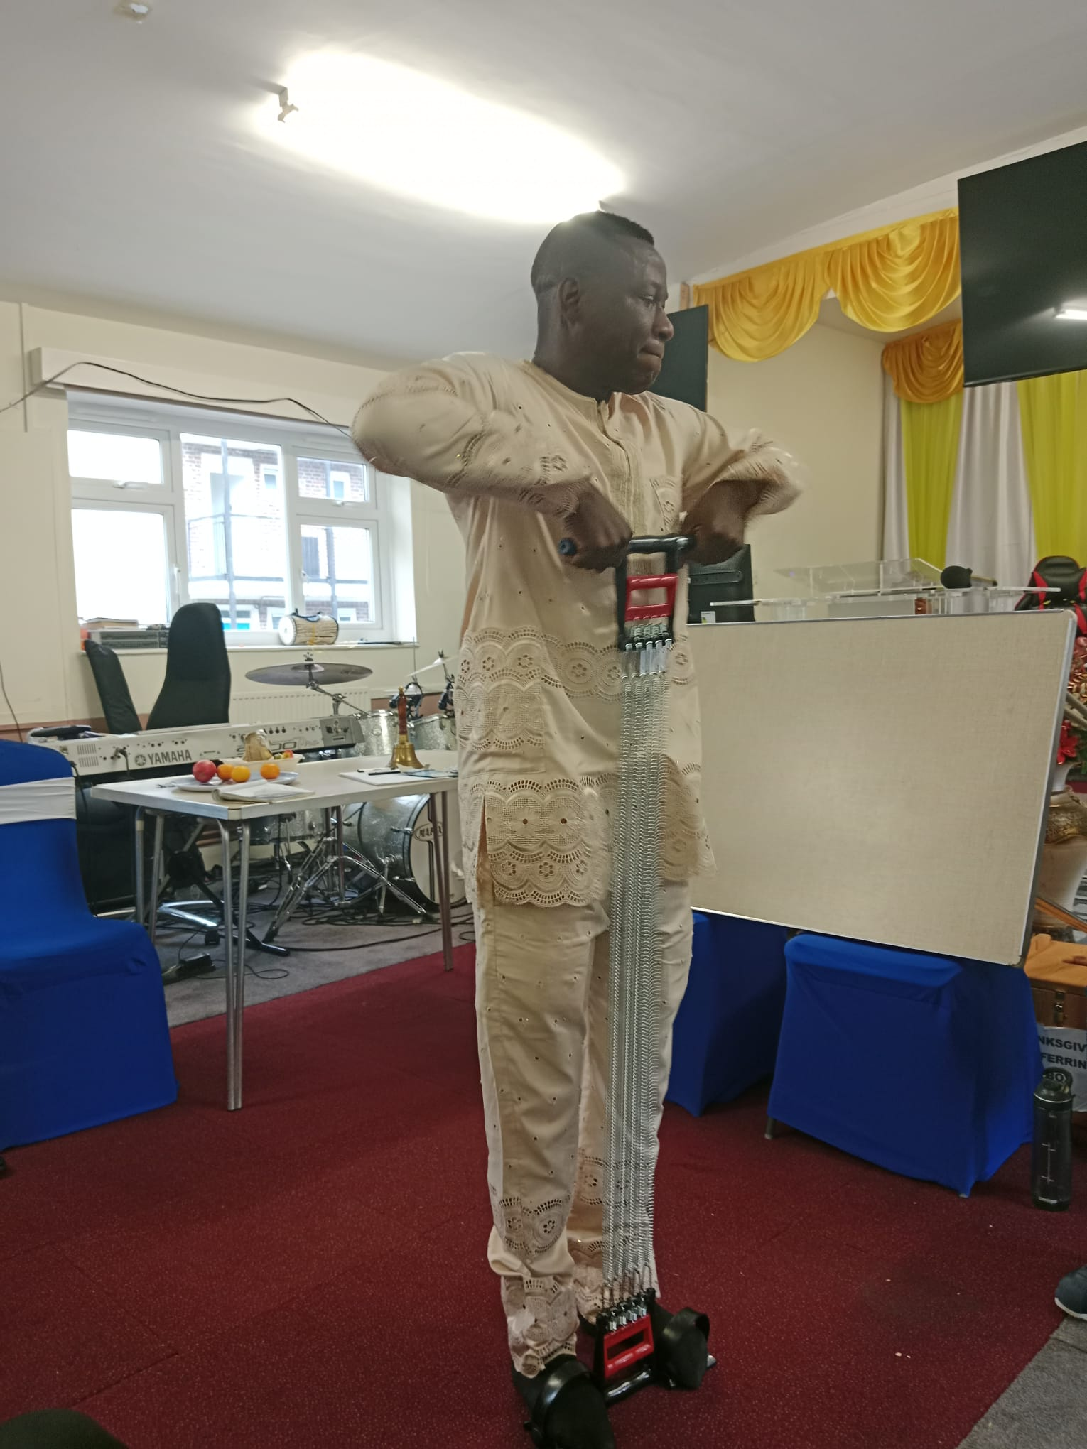
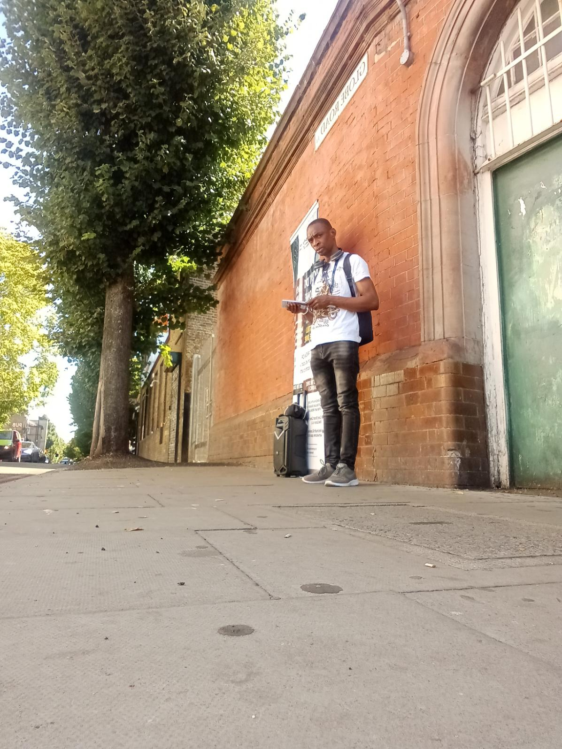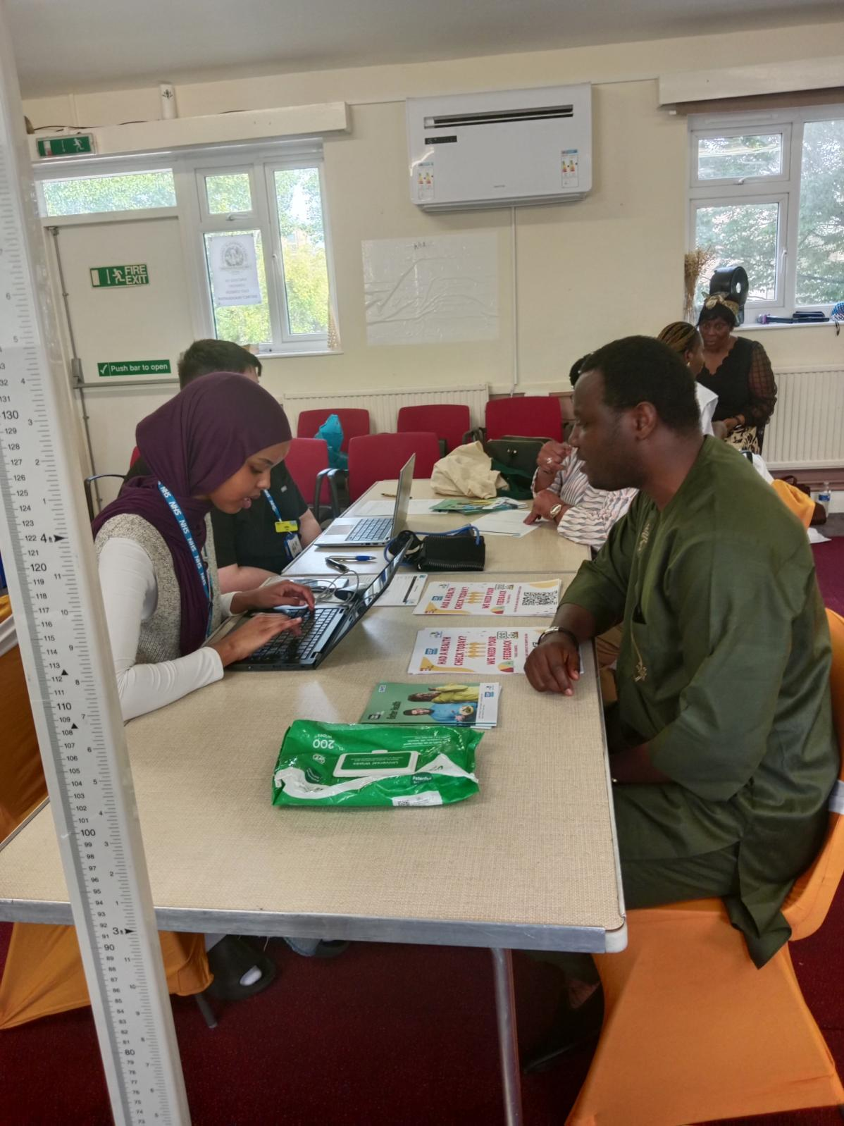
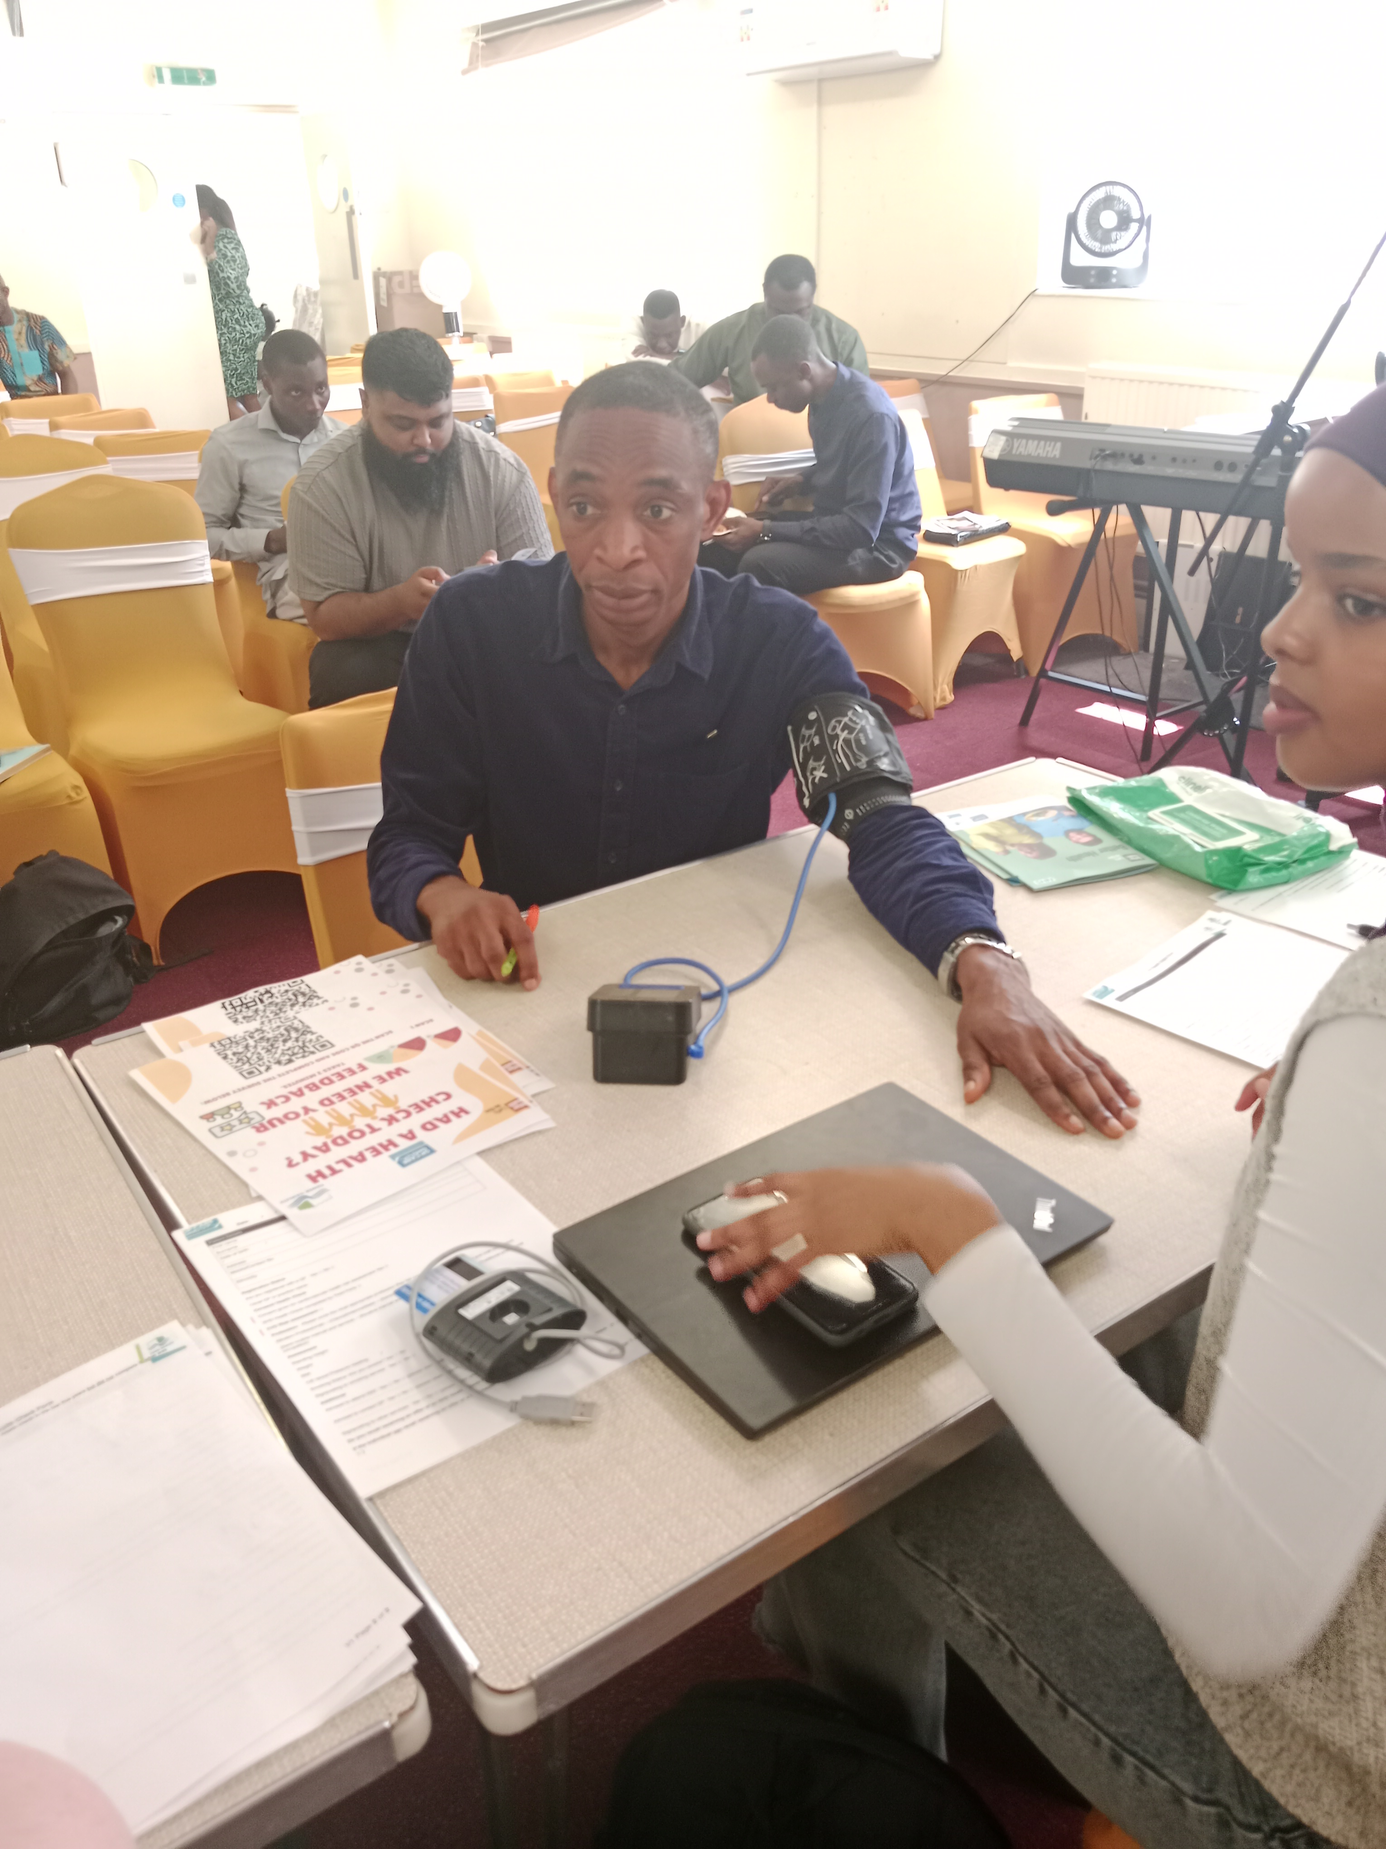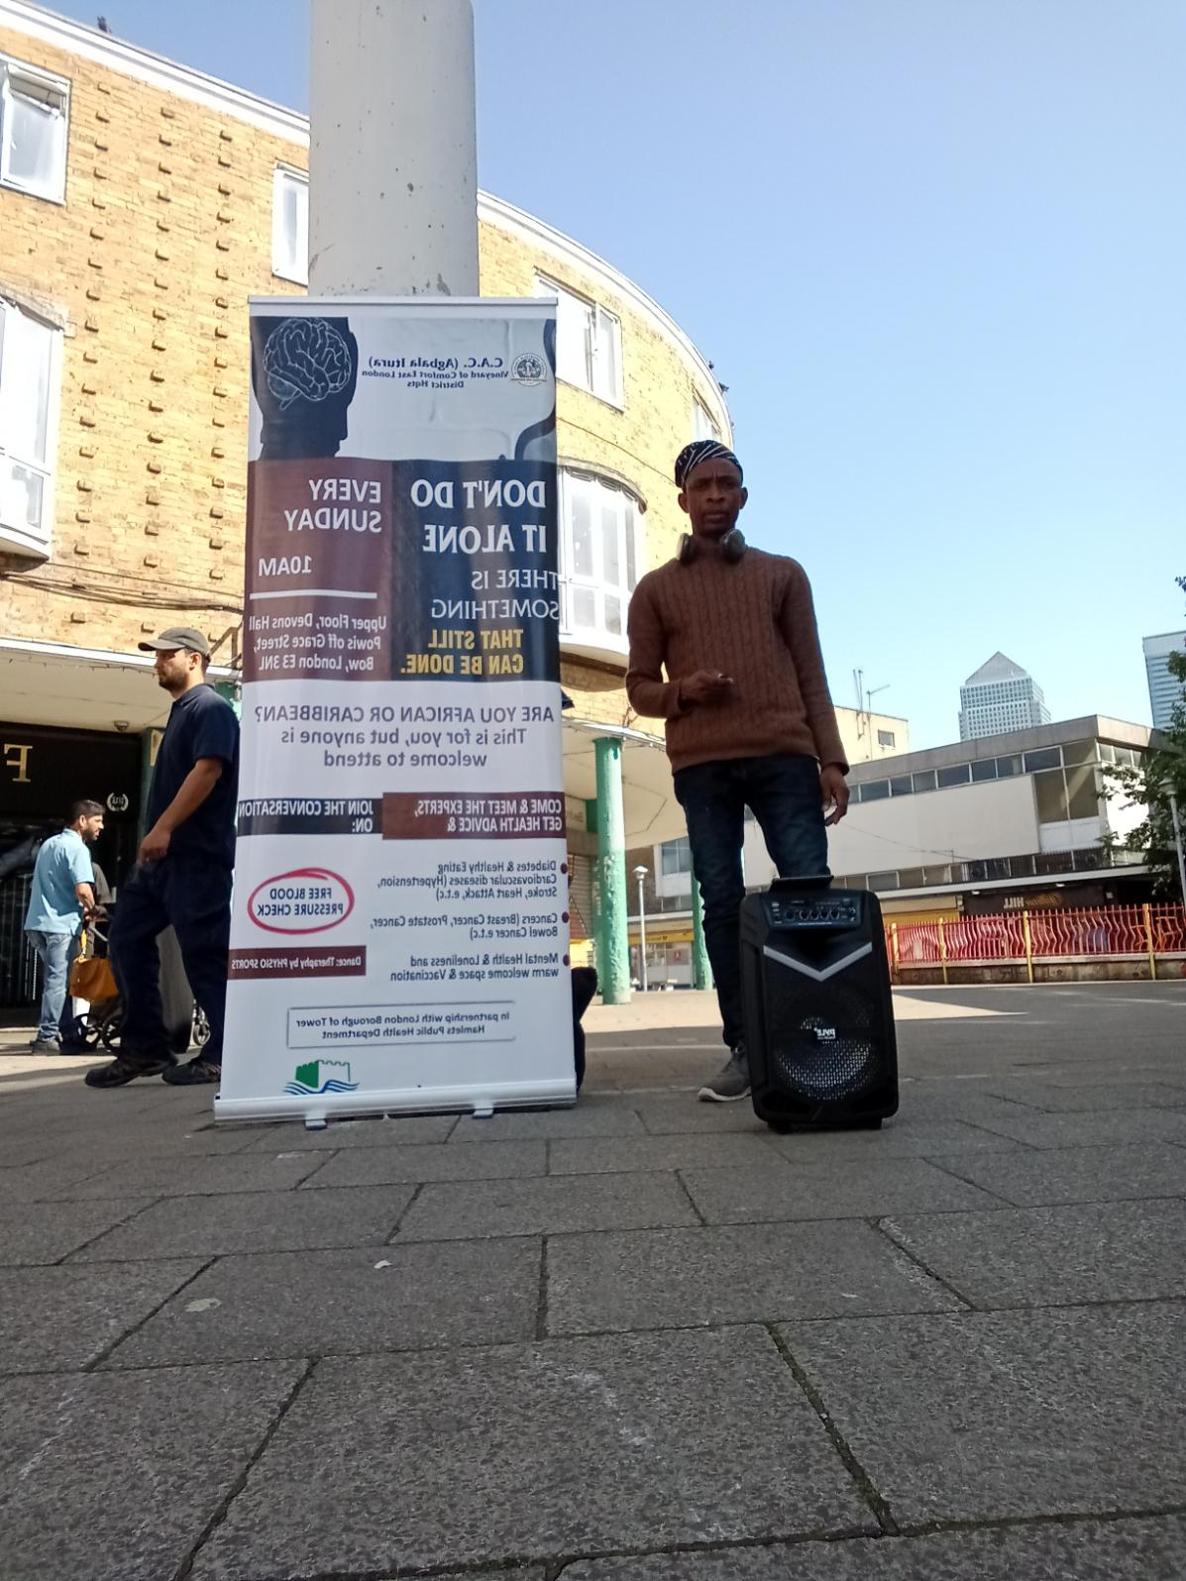
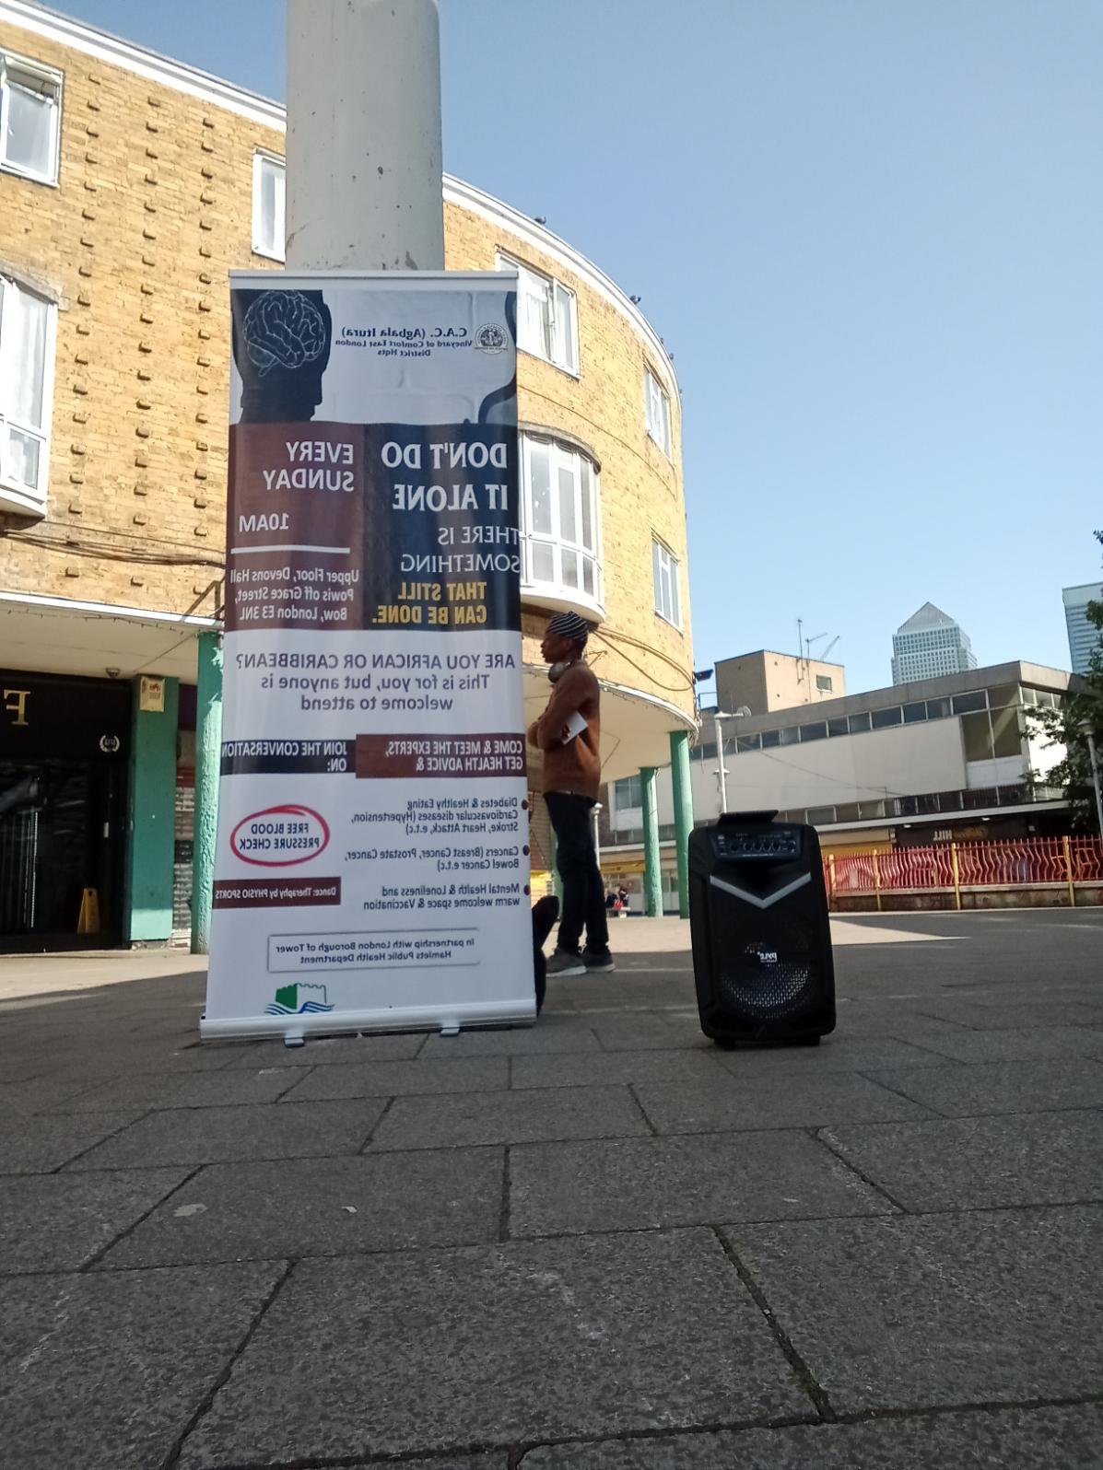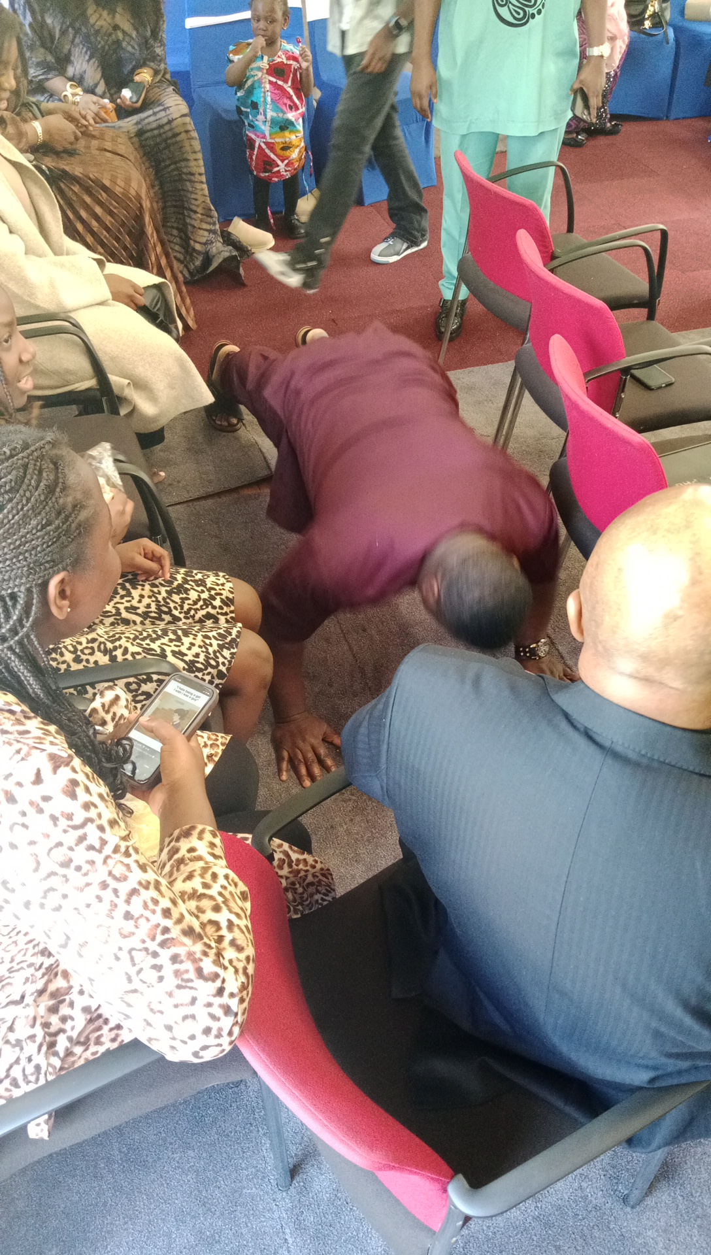

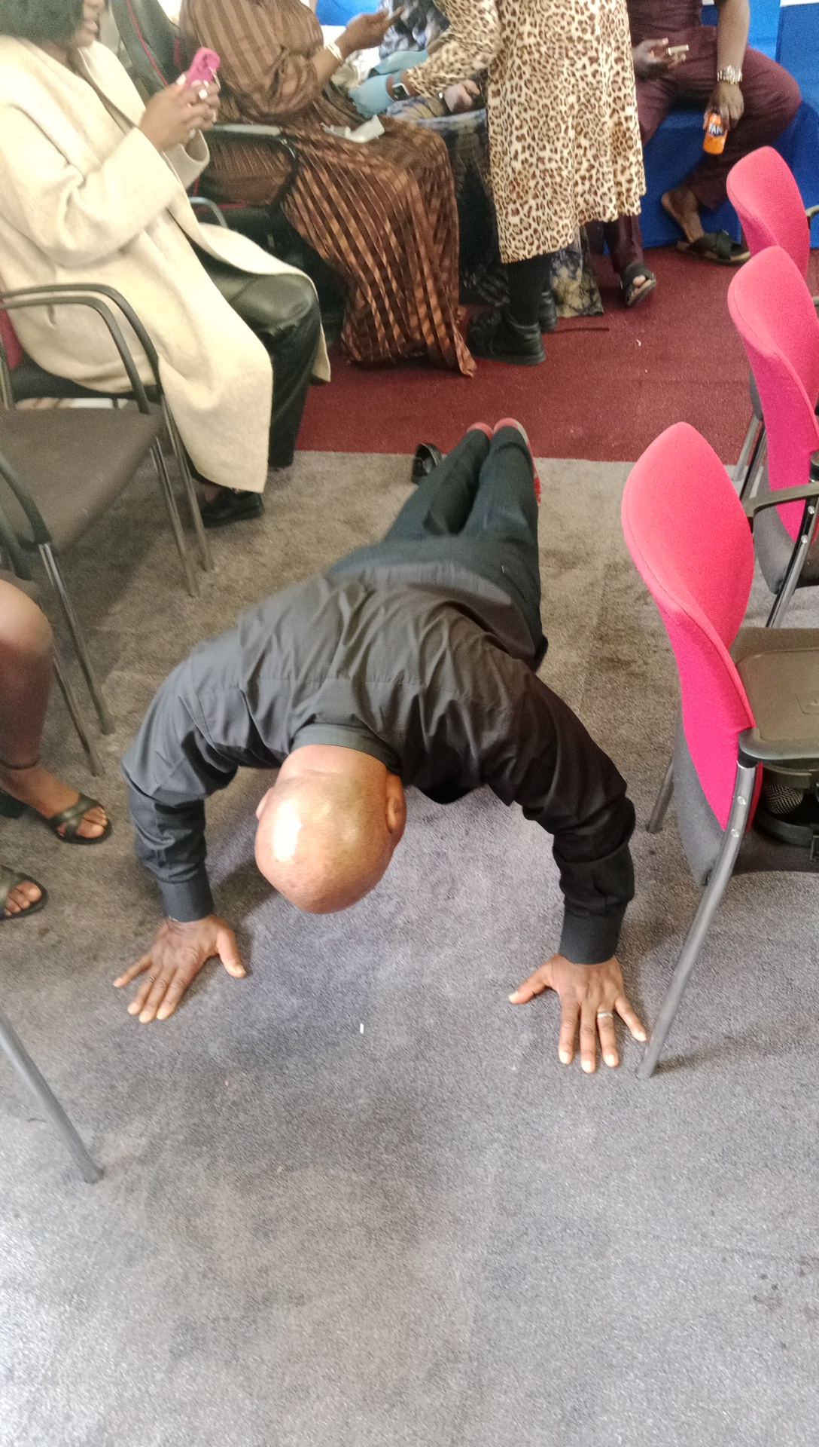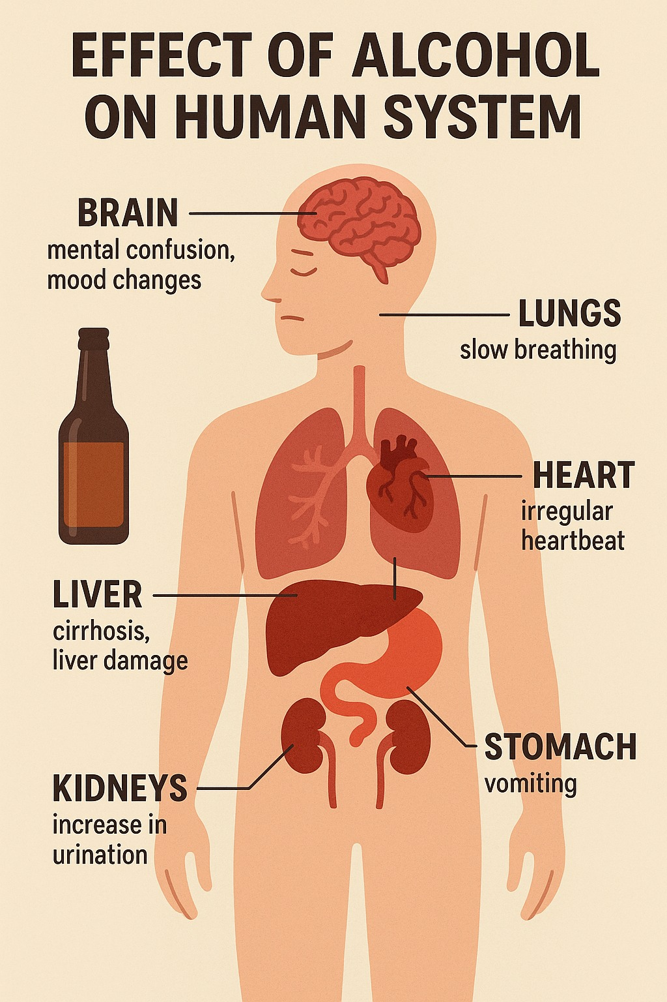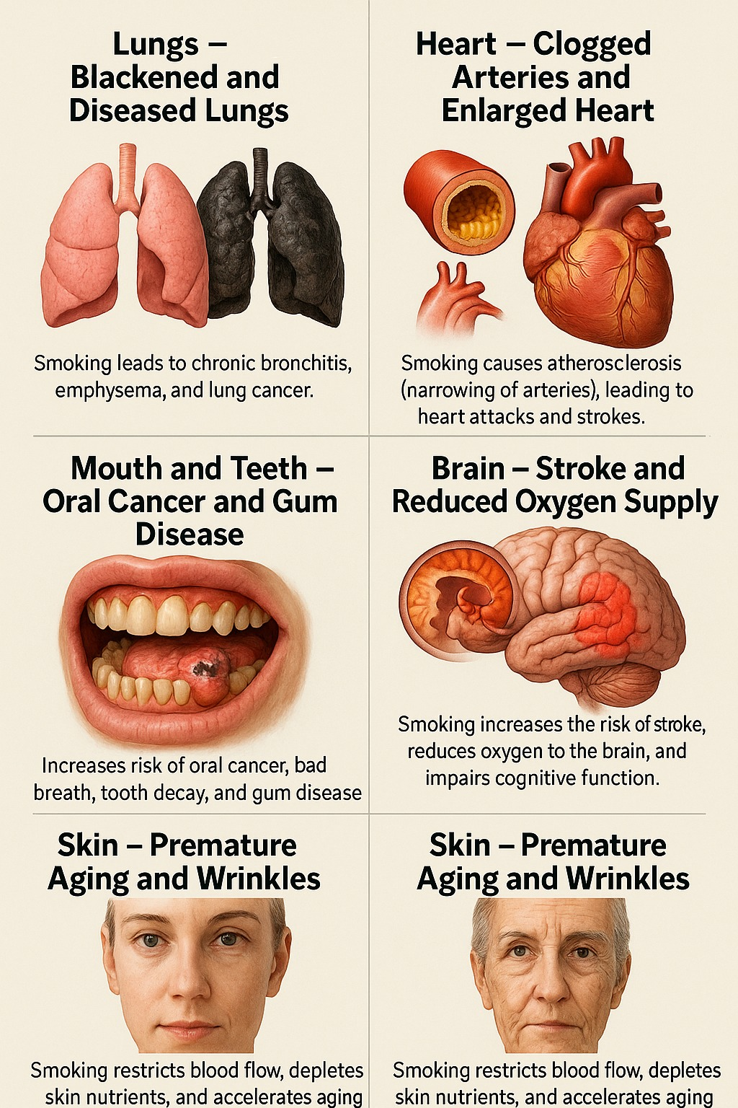

In conclusion, in the recent published document on longterm conditions in Tower Hamlets, the difference between the highest demography of suffers of Longterm conditions is not far fetched from people from Black African and Caribbean descent.
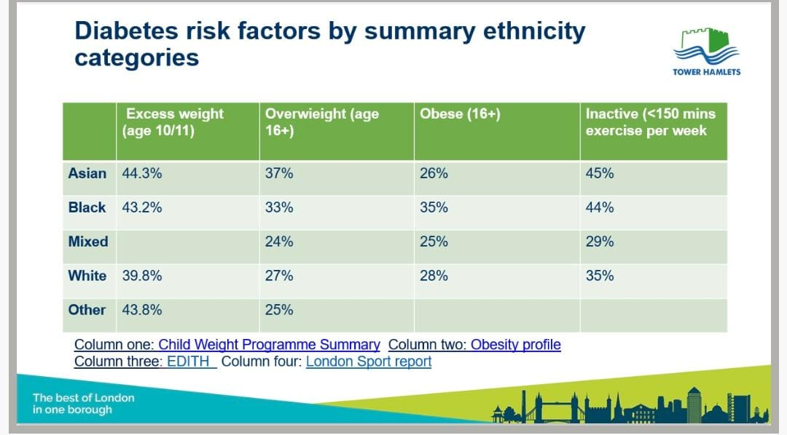
In fact, the risk of Longterm conditions between Bangladesh and Black African and Caribbean people is less than 1%, (see attached) which makes continuing the current project in Black African faith settings a must, if we are truly talking about prevention.

